### Story 1: Pre-Arrival SM Use to Post-Arrival Outcome

*Structure: Pre-arrival social media use, then intermediary networks/contacts and search strategies, and then post-arrival labour outcomes.*

#### Introduction

(key points: difficult time settling into a new country; social media has great potential to help; but are immigrants using?; if no, why not?; if yes, is it as effective as it could be?)

We went out and asked 500 recent immigrants to Canada, how did social media help them learn about work prospects in Canada.

AT THE SAME TIME: we’ve learned SSPO and don't use social media a lot (only 20%)- They want to know where do they invest their time building capacity to be most effective in supporting immigrants?

#### Pre-Arrival

What social media platforms were used to find information about working in Canada?

(A - key points: high percentage of incoming immigrants are online looking for information before coming to Canada; and as many as 65% are using social media; Facebook, for example, is almost as important in information search as making a direct email or phone call) Other important channels: Linked, QZone, online discussion forums)

If we look at this by gender, the picture looks different - Facebook surpasses even making direct phone calls or emails!!

* Overall SM strategy (graph 2 from tableau infographic)
  + give option to segment by gender and/or age (button or dropdown)
  + could also have a map for where people come from
* Frequency of Platform Usage (graph 5) (not sure if this is adding insights on top of graph 2)

#### Intermediate

*\* Data for intermediate section for order of connections might not exist.*

(B- Key point - Immigrants are combing the social media environment for key information and services; but rely on a set few platforms, primarily.

SSPO users can use the interactive tool to see what platforms immigrants use for different services and information.)

* Newcomers use of SM platforms (graph 6)
  + either filtering options or multiple side-by-side
* Newcomers Experiences (graph 3) - probably not need to visualize

C- We asked what was the experience like? Did they find what they were looking for?

Aaa oHHHH!

Too many thought they did not have the right skills or that they did not trust the information?

Stein’s graph #4

D- …And how did their use of social media affect their ability to get established in the labour market?

* In the first six months of arrival, those who used social media had big advantage in getting established in the labour market (3 to 1 advantage)
* Those using social media tend to earn more in their first job than those who don't;
* Social media users are more likely to find work that better matches their credentials

[may be we use only: employment, earnings, and job match]

#### Post-Arrival

* Compare labour market outcomes (employment 3-6 months after arrival)
* Labour Market Outcomes (graph 4) with button or dropdown options
* Key points
  + Those who use SM (80%) found work within 3-6 months. Those who didn't (20%) found work. The gap between those who use SM and those who didn't is big here.
  + Compare to 1 month find work (70-30). Those who used SM before had an advantage.
  + List the advantages in terms of found work at different stages.
  + List advantages in terms of wages/precarity.
  + Basically, labour market outcomes is the main takeaway. Question: why is SM linked to those labour market outcomes?
  + SSPOs need to recognize that this gap exists.

#### Conclusion

What this means SSPO

* Can take a look at the services they currently provide (types of information and services) and determine what platform they should sue
* This helps them focus in on maximize their own capacity a ccoridng strategic choic eof platform Analyze a platform - make a decision on where to put thei rlearning/ programming efforts

#### Footer

Make sure to have a footer section with where readers can get the data

# Things that are needed

https://losingtime.ca/infovis/Social Media/

1. Images for the introduction header
2. Text for the introduction to introduce the project and the data.
3. Mixing resources…can we sort the x-axis based on highest to lowest
4. Re-ordering the platforms in the graph with shortened titles, replace ‘or’ with commas

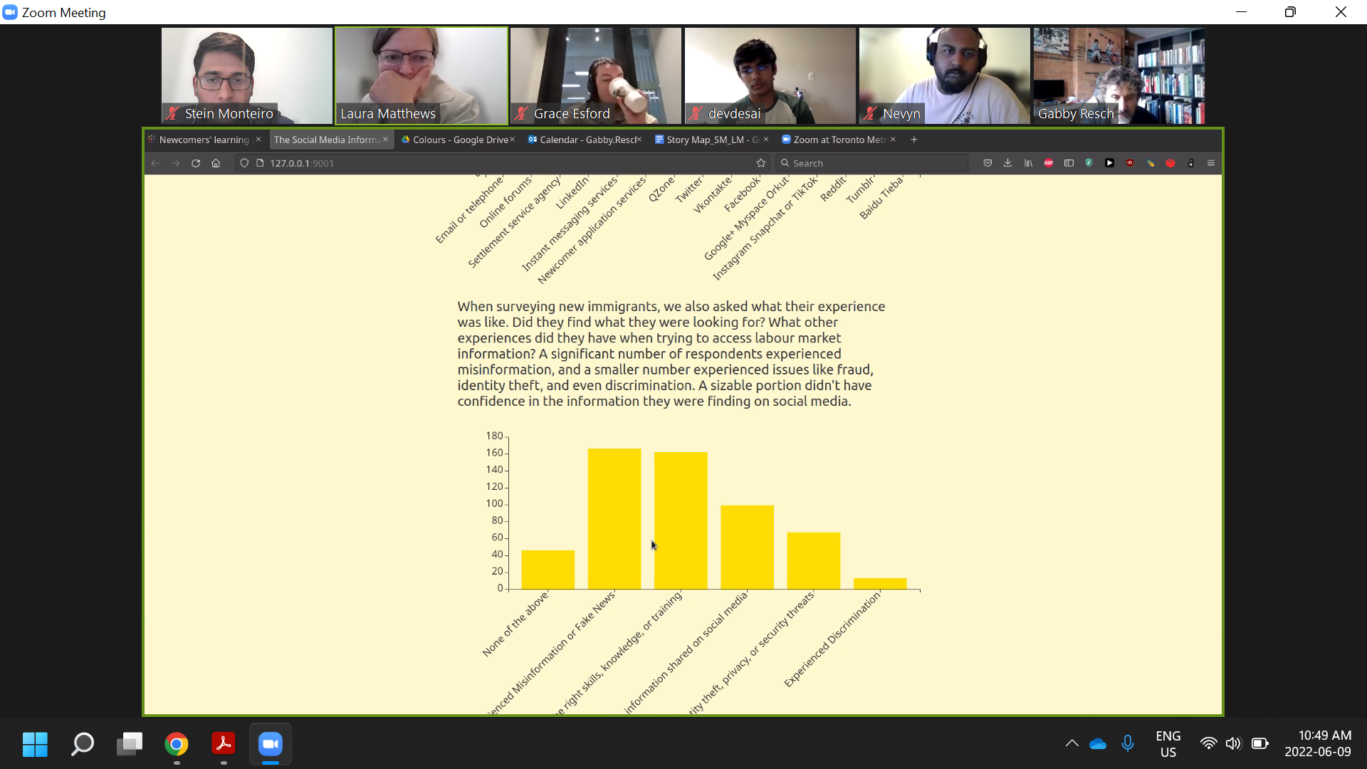

1. Close the gap! Section needs concluding text

### Story 2: labour market outcome differences based on types of social media apps

(and maybe the countries that primarily use those apps - e.g. brazil whatsapp) https://docs.google.com/presentation/d/1bcHEVkOXUWELFxMBEB4BOfYT-biF-E91jyrnP2UDXQY/edit#slide=id.g127515c4776_0_2

- Different SM for different country types

- Filtering based on

### Story 3: Comparison between India and China or comparison between gender

### Story 4: takeaway is targeting. SSPOs can target better. (that can be for a next story.)

### Story 5: Misinformation. SSPOs working with platforms trying to cut down on misinformation

### Story 6:

### Story 7: